The program of test score and train score by finding out the accuracy of a given dataset that can be visualized by the code below:

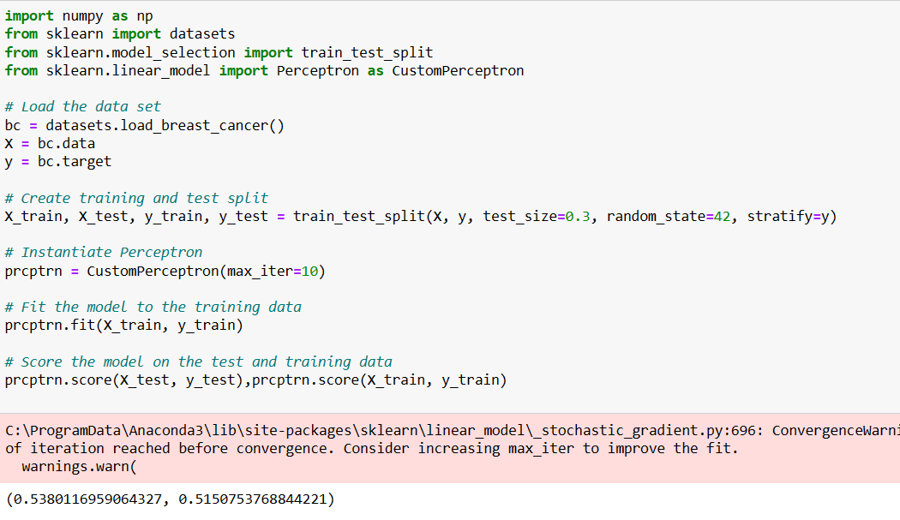

Inbuilt dataset present in the sklearn module and tried to find the accuracy of the given dataset.

The following list containing the epoch’s can be created to obtain the data set:

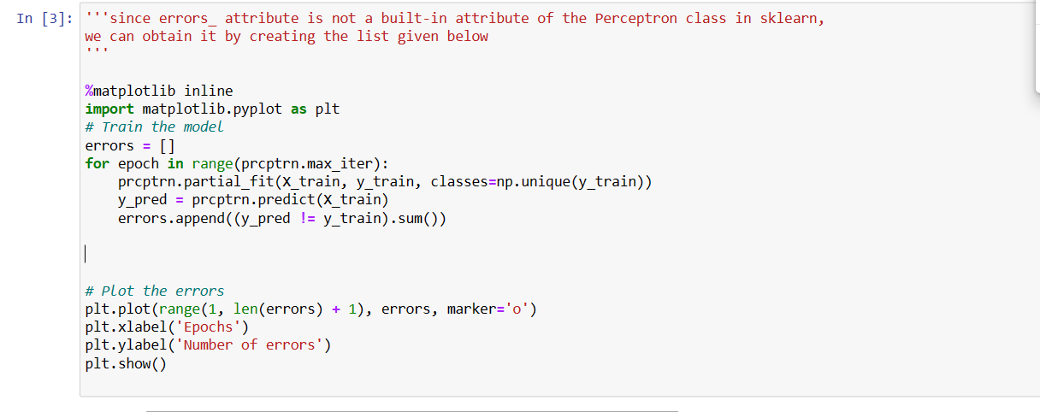

These epochs are plotted with respect to their errors and we obtain the following graph:  
